**Case Study 2. Southern Africa and beyond: Conservation Agriculture**

|  |
| --- |
| **Abstract**  Conservation Agriculture is a form of minimum-tillage agriculture which has become established in parts of southern Africa and elsewhere which are experiencing less rainfall now than in the recent past. The technology package increases crop yields with reduced production costs, thus leading to both increased food availability and farm profitability. Conservation Agriculture thereby has the capacity to raise the level of farming from subsistence to commercial, and has the support of both the European Union and FAO. Conservation Agriculture can also lead to social engineering in favor of women’s empowerment and gender equity, and its popularity is spreading, CA being seen as climate-smart technology. |

Key words: minimum tillage, mechanization, crop rotation, soil cover, herbicide and planting basin; profitability; social engineering; IACCA

**2.1. Introduction**

Conservation Agriculture (CA)(*syn.* conservation farming) was originally developed in the drier areas of USA (State of Nebraska) in the 1940s in an attempt to control wind erosion. CA has mainly been driven by farmers in North and South America and Australia, who found that conventional tillage resulted in unacceptable levels of soil erosion. Currently, there are about 1.5 billion ha of arable land in the world, though this is decreasing by some 1% per year due to erosion, roads and other physical infrastructure. This trend is clearly unsustainable. CA significantly reduces erosion, making farming more sustainable. About 100 million ha of land are now under CA, worldwide.   
  
CA has since been adapted to other parts of the world, with the support of FAO and IFAD *et al.*, for instance proving itself in southern Africa (South Africa, Zimbabwe and Zambia)(FAO, 2011a). As an example, corn grown under CA during the 2008/09 cropping season yielded 3,000kg/ha and 1,780kg/ha grain in Zambia and Zimbabwe respectively, an increase of 42 percent and 105 percent over yields under ‘control’ conventional draft tillage in those two countries. Gross margins in Zambia were $US44/ha under CA compared with only $US19/ha for conventional tillage, whilst the respective figures for Zimbabwe were $US213/ha and $US61/ha (Mazvimavi and Twomlow, 2009).  
  
South America, especially Argentina and Brazil, are far ahead of Africa in the implementation of CA.  This is because farmers in those two countries own their land, and so take care of it.  When South American farmers saw their land disappearing as a result of water erosion, they went to the USA to find answers to the problem. South America now has a significant agro-mechanization industry making CA equipment (the Brazilian companies Fitarelli and Knapik, for instance).

CA comprises a package of agricultural practices based on three main principles – minimum tillage, permanent organic soil cover and crop rotation (diversification of crop species grown in associations or sequence). The initial three years of establishment are the most time-consuming and least remunerative. No two farms are the same, and each participating farmer will need to find the best way to implement CA. One of the first tasks in setting up the system is to mark out in the dry season the planting basins for the intended main crop. These will be permanent, marked by hoe or in rip lines using mechanization. The spaces between the rows remain uncultivated, in order to seal stored moisture in the soil, yet covered with dead organic mulch. Surface weed seeds which germinate in the inter-row areas in the first season are controlled by the mulch or herbicide. In subsequent seasons, because the remaining weed seeds in the inter-rows are buried deep, few germinate, and with each season weed infestation declines. Rainwater will plane off the inter-rows into the rip lines, where it is needed. Both crop seeds and fertiliser are placed solely in the rows, normally using an ox- or tractor-drawn planter/ fertilizer applicator.   
  
The advantages of CA to farmers include reduced workloads, better weed control, higher yields, reduced soil erosion and improved organic matter content, reduced costs of production and higher profitability. Fuel use, for instance, is cut drastically under CA; in South Africa, 99 l/ha of fuel are needed to produce a hectare of corn under conventional tillage, compared with only 33 l/ha under CA. By making around 30% better use of available rainfall, CA renders farming viable in areas where it is otherwise a more risky activity.  

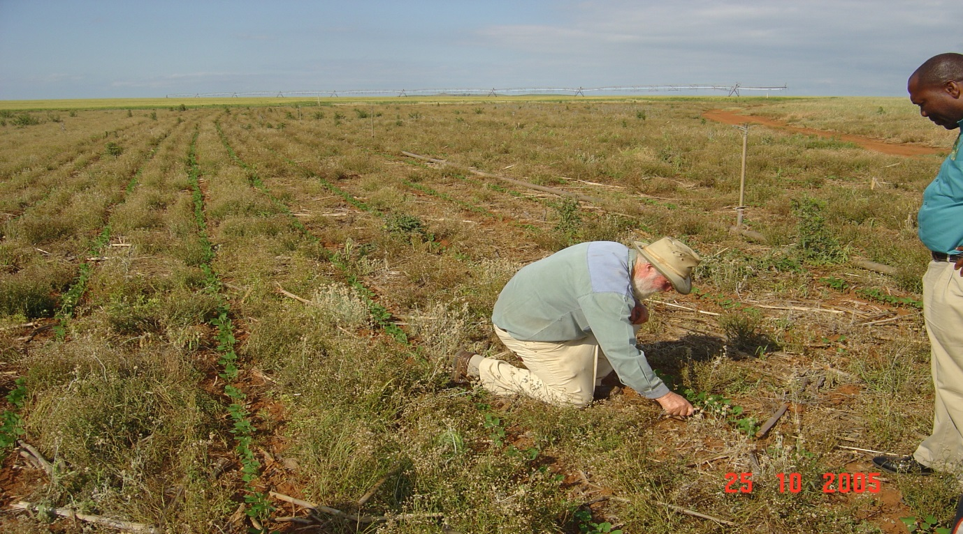

Photo 2.1. Soya planted by a 4-row drill into herbicide-treated weeds on Anthony Muirhead’s farm at Winterton, in the foothills of the Drakensberg mountains, KwaZulu-Natal (KZN), South Africa (photograph by James Breen, FAO Emergency Coordinator, October 2005).

By 2005, up to 1 million ha of South Africa was under some form of reduced tillage, most of it in Kwazulu Natal. It is difficult to obtain permanent soil cover under conditions prevailing in South Africa, it having an average of only 500mm per year, and down to 250mm in western KZN. CA has been successfully adopted in Eastern Cape with winter crops, and the adoption rate is increasing due to environmental concerns and increasing fuel costs in farming (the power requirement to cultivate a field under CA is only 40 per cent of that for conventional tillage). The view of the Agricultural Research Council at Cedara in KZN is that almost all of the advantages of CA in the area derive not from not tilling the soil *per se*, but from maintaining a permanent soil cover, thereby minimising erosion by wind and water (through increasing absorptive capacity of the field – Mr Muirhead says as much as 4x more).   
  
Based on the increased yields under CA, almost all the farmers in the Karkloof Valley in the KZN Midlands have converted to it. As a result, the river running through the valley is noticeably clearer than rivers in neighbouring areas where CA is not practiced and the number of fish species in that river has increased. Because of the increased scenic value, even the number of tourists using the biking trails seems to have increased. The increased absorptive capacity of the soil reduces the need for supplementary irrigation, even rendering it un-necessary. Hence, the importance of keeping the soil covered by a crop, or the residues of the previous crop and any weed cover that is killed using herbicide prior to crop seed germination. Maintaining total soil cover has been solved in Lesotho using various cover crops such as oats, wheat and various deep-rooted legumes. Total soil cover is seen in the photograph below, in Kenya.

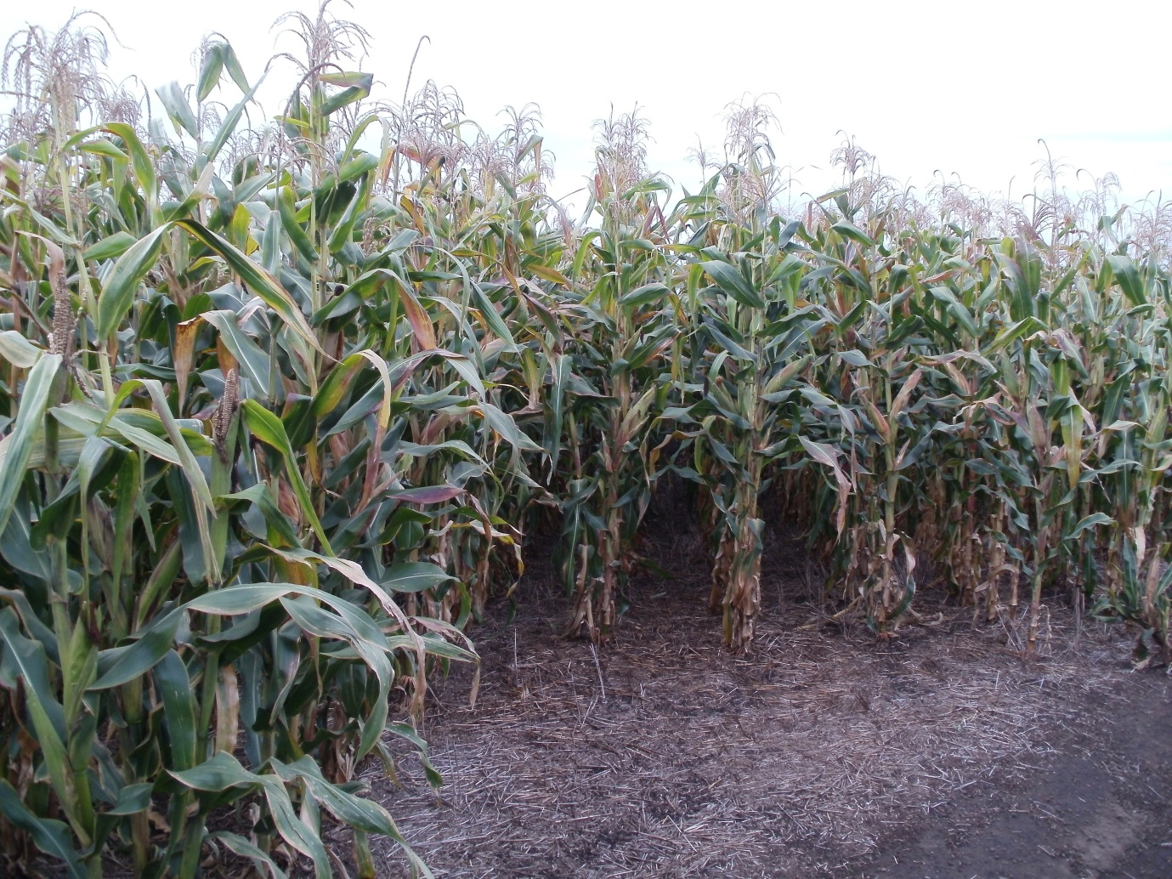

Photo 2.2. A crop of corn planted into wheat stubble, on a large farm in the Kenyan Rift Valley (photograph by Sina Luchen, Regional FAO agronomist, Johannesburg, South Africa).  
  
Field mechanisation to achieve CA comes in various ‘sizes’. Animal draft is common on smallholdings, using a single blade to rip one furrow at a time. A technological step above that is shown in the five photographs below, taken in Indonesia. Such implements can easily be handled by women, who find the heavier ploughs used in traditional tillage too cumbersome to work with for a long period. Hence, CA is not only a climate-smart technology, but gender-sensitive too.

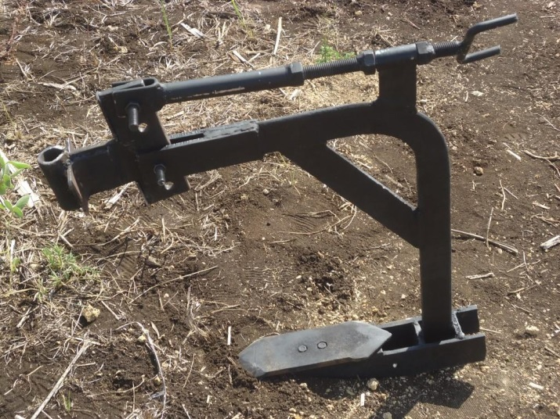

Photo 2.3. The ‘Lombok ripper’, manufactured in Lombok, West Nusa Tenggara (WNT) Province, Indonesia  
  
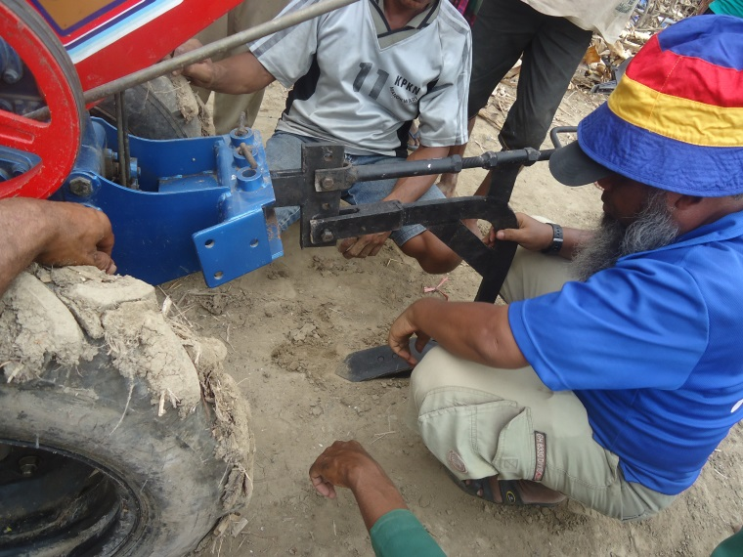  
  
Photo 2.4. Assembling the ripper and testing it at Malaka, Bogor, Jawa Barat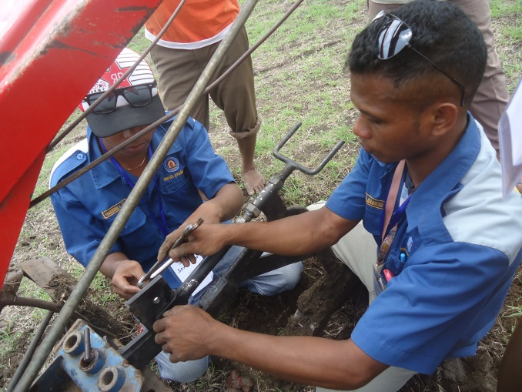Photo 2.5. Kupang Polytechnic students working with the ripper in Timor Tengah Utara **(**TTU)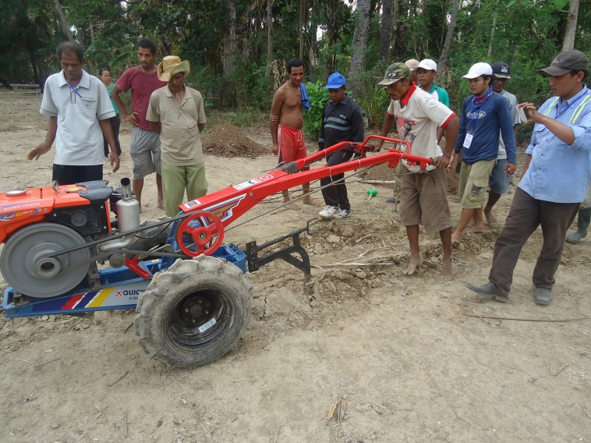Photo 2.6. Ripping during trials at Malaka 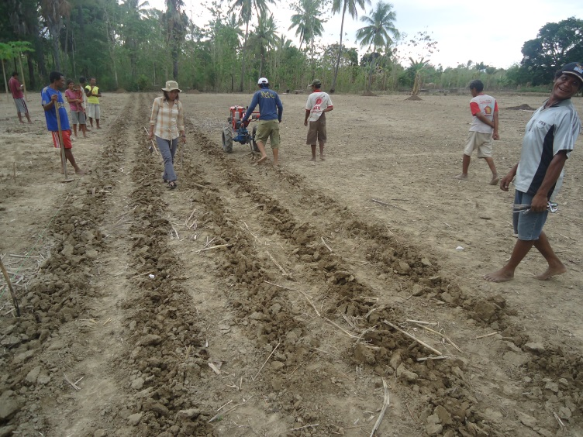

Photo 2.7. Training session in CA for students in Indonesia (photographs courtesy of John Weatherson, FAO Conservation Agriculture Advisor, ‘Reducing Disaster Risks Caused by Climate Change in NTB and NTT Provinces’, Indonesia). **2.2. Zambia and Conservation Agriculture**

Zambia has some of the best land endowment in Africa, half of its 753,000km**2** being fertile, though only around 15 percent of that land is cultivated. More than 80 percent of the national food requirement is produced by smallholders, using outdated farming practices and progressive soil degradation has occurred. The relatively high incidence of HIV/AIDS has a negative impact on farm labor availability. Increases in yield have been constrained by poor and unreliable rainfall, and sub-optimal infrastructure – especially good all-weather roads, and grain storage silos – hardly any more have been built since the end of the colonial era in 1964.

The agricultural sector is hugely under-developed, though offers considerable potential for sovereign food security, reducing poverty and undernutrition (Chapter 3.2 in the companion book), import reduction and export to neighboring countries. The sector employs 67 percent of the labor force and provides the main opportunity of income and employment for women, who constitute 65 percent of the rural population.

Improvements to Zambia's agricultural productive capacity has been constrained by limited access to credit resources to capitalise farm operations, reliable input supplies (particularly fertilizer, herbicides, seeds), market information and the lack of commercial processing companies in rural areas. Smallholders are not properly engaging with markets, due to poor infrastructure which increases transactional costs, reducing profitability.

The agricultural sector is acknowledged by the Zambian government as the engine for national growth and poverty reduction, given that agriculture is the main economic activity and the prime source of food and income for the rural poor. In Zambia, CA is enshrined in the government’s agricultural policy framework, included for example in the National Agriculture Investment Program (2014-18), and the Director of Agriculture wishes to reinforce CA training of his staff. The practice is strongly supported by the government, as a contribution to its agricultural diversification policy agenda, which promotes productivity and improved dietary diversity aimed at reducing stunting levels in children. 45 percent of the country’s children below five years of age suffer from chronic undernutrition, which is well above the average in sub-Saharan Africa, and has hardly improved since the 1990s.

CA has been promoted in seven of the country’s nine provinces since the 1980s. It was introduced in response to the ending of subsidies for corn seed, fertilizer and farm machinery, which event was precipitated by the collapse of copper prices in 1974 and government’s subsequent withdrawal of subsidies for farm inputs. Farmers were then faced with the prospect of perpetually low corn yields from their degraded soils. When CA was first introduced into Zambia, in 1985 with SIDA funding, CA was initially seen as a way to improve yields through maximising the use of stored soil water, and this rationale has intensified with the onset of ‘climate change’ and decreasing rainfall. Over the last 30 years, other donors and projects have become involved in helping government promote the climate-smart practice[1].   
  
The supply response on farms participating in a CA-pilot with medium to full inputs availed, was measured by the FAO Emergency Unit as from 1.1t corn grain per/ha to 5t/ha, and even up to 8t/ha sometimes). Lady farmers near Monze town enthused to the current author “We feel like white farmers now !”, meaning that their yields had increased[2], and because the hitherto huge time burden of initial tilling the whole field surface and subsequent inter-row weeding is a thing of the past, they had ‘free time’ that they had never had before. They used this for making pottery for sale and extending their poultry production[3]. As there is no longer the need for the whole field to be ploughed, and that the single-pass Fitarelli ripper and planter is lightweight, women can now manage using ox draft, whereas the heavier plough used before was more than a woman could handle. CA has therefore contributed to social engineering, in terms of improved women’s empowerment and gender equity in the community. The single-pass ripper and planter also has a fertilizer box, ensuring that diammonium phosphate (DAP) is placed below the seed in the row, to boost seedling growth.

A major agricultural input supplier in Monze town opined to the current author that CA and the EU Food Facility support for it in 2009-10 had brought Ministry of Agriculture and Livestock (MAL) extension services, farmers and suppliers into a unified agricultural community with an enhanced rapport, in which goals and successes were shared and inter-dependent. Furthermore, farmers at Manvule Information Center at Mumbwa in Central Province declaimed that CA had built their confidence, transforming their perception in the community to that of ‘real’ farmers, no longer merely ‘subsistence’.

**2.3. Conservation Agriculture outreach**

In addition to the countries mentioned above (Brazil, Argentina, Zambia, South Africa, Zimbabwe, Kenya and Indonesia), large scale commercial CA is also being undertaken in other countries - Sudan and Angola for instance, managed by a South African company, Golder Associates of Durban, and in Tanzania. Downstream of the realisation that climate change is already negatively affecting much of global agriculture (Chapters 5.5.1 and 6.9 in the companion book), a new buzzword has emerged, that of ‘Climate-smart Agriculture’, in order to maximise agricultural productivity per unit of water in pursuit of enhanced food security (see Section 2.2 above). Yet this has been a goal of CA and minimum-tillage agriculture for decades, and the two initiatives are seen as convergent and complementary.

Just how seriously CA is being taken in Africa and elsewhere is demonstrated by the Declaration (Communiqué) of the First Africa Congress on Conservation Agriculture, which was held in Lusaka in March 2014, and attended by delegates from many countries, not just Zambia (Box 2.1 below)(quoted with permission).

|  |
| --- |
| **Box 2.1. Declaration of the First Africa Congress on Conservation Agriculture**    **A. Background**  The African Conservation Tillage Network (ACT) in close liaison with partners convened the 1st Africa Congress on Conservation Agriculture (IACCA) in Lusaka, Zambia, from 18th to 21st March 2014. This was held under the theme *“Conservation Agriculture (CA): Building entrepreneurship and resilient farming systems”.* The Congress brought together 414 delegates from 42 African and other countries of the world to share experiences and lessons and facilitate alliances to unblock hindrances to expanded and scaled-up adoption of CA, especially among the smallholder farming systems and related industry in Africa.  The congress was convened in the backdrop that 2014 has been designated by African Union Heads of State and Governments as the year for agriculture and food security, and marks the 10th anniversary of Comprehensive African Agriculture Development Program (CAADP). It also marks the adoption of a new CAADP results framework, which recognizes the role of climate-smart agriculture in addressing agriculture and climate change challenges.  This is in addition to the fact that, while worldwide hunger has decreased by 132 million people in the last 20 years, it has increased by 64 million (from 175 to 239 million) in Africa over the same period. Africa as a continent has remained a net importer of agricultural products in the last three decades. In 1980, Africa had an almost balanced agricultural trade when both agricultural exports and imports were at about USD 14 billion, but by 2007 its agricultural imports exceeded agricultural exports by about USD 22 billion. While global population is projected, by 2013 basis, to increase by 33% to 9 billion people by 2050, Africa's population is projected to increase by 115% (from 1.1 to 2.39 billion) by the same date; thus requiring a similar increase in food production. These figures point to the reality that urgent efforts are needed to transform agricultural production on the continent, in line with the CAADP framework to which African governments have pledged their support.  Conservation Agriculture is defined as a management system based on three principles that should be applied in a mutually reinforcing manner: minimum physical soil disturbance, permanent soil cover with live or dead plant material, and crop diversification in space and time. CA is now spreading at the annual rate of some 10 million hectares, and covers more than 130 million hectares globally. CA is a production system which uses all appropriate best management practices to minimize risks and ensure ecological sustainability and resilience to underpin economic and social sustainability.  **B. Preamble**  **We, the CA stakeholders attending the First Africa Congress on Conservation Agriculture meeting in Lusaka from the 18th to 21st of March 2014:**  - Acknowledging that CA is set to become a major contributor to achieving CAADP’s goal 6% annual growth in the agricultural sector which employs 80% of Africa’s rural population;  - Noting the documented impact and feedback from practicing CA farmers across Africa and in other developing regions, and its significantly positive impact on their incomes, livelihood, well-being and on empowerment of women farmers;  - Further noting that CA is one of the best food security and profitability options for farmers, in addition to being a climate-smart and environmentally sustainable solution that gives farmers the choice to apply CA principles to a range of production systems including, horticulture, agroforestry and crop-livestock integration, amongst others;  - Recognizing that governments are making great efforts in support of Food Security and sustainable agriculture intensification in general, but that these efforts need to be stepped up to create a more conducive environment for the adoption of Conservation Agriculture;  - Further recognizing the necessity of promoting farmer associations and platforms and strengthening their partnerships with governments;  - Realizing the need to strengthen partnerships, communication and information flow within the CA community of practice at national and regional levels;  - Considering that new knowledge and experience exchange are an important resource for uptake and spread of CA;  - Further considering that CA is a key to enhancing the capacity of all farmers to adapt to climate change effects;  - Underlining the importance of the three inter-linked principles of CA – minimum soil disturbance, maintenance of soil cover and cropping system diversity;  - Highlighting the crucial need to upscale mainstreaming of education on the science and practice of CA in existing educational systems at primary, secondary and tertiary levels;  - Further realizing the importance of South-South cooperation, in the form of exchange of expertise, information and experience; and  - Also recognizing the role played by women and the youth in the accelerated upscaling and adoption of CA; resolve as follows:  **C. The Resolve**  **In order to achieve the CAADP goal of 6% growth of the agricultural sector, we resolve that:**  **POLICY, POLITICAL COMMITMENT AND LEADERSHIP**  1. We call for commitment from all national and international stakeholders in the public, private and civil sectors to support the up-scaling of CA as a climate-smart technology to reach at least 25 million farmers across Africa by 2025;  2. Governments are called upon to create a conducive environment for the adoption and development of CA by investing more in CA education and extension; integrating CA training in educational curricula, and supporting CA farmers and their organizations.  3. Governments are called upon to create an enabling policy environment to allow investment financing, and technological development including private sector involvement in CA related value chains;  4. Development partners are urged to increase support to CA programs under the CAADP Agriculture climate agenda;  **PRIVATE SECTOR ENGAGEMENT**  5. Urge the Private sector to proactively support up scaling of CA through further innovations and increased investments financing in appropriate CA technologies and related services;  **TRAINING, EXTENSION, RESEARCH AND INNOVATION, AND KNOWLEDGE SUPPORT**  6. ACT is to establish a quality-assurance system for accredited agricultural training institutions to provide CA training certificates. Furthermore, ACT will collaborate with relevant stakeholders for the harmonization of CA training curricula;  7. Farmers who have adopted CA should be supported to be champions and educators for their counterparts. Furthermore, they should establish locally relevant collaborations, innovation platforms and associations that can engage with government and other CA actors;  8. Agricultural training institutions are requested to take up CA as an integral part of their training programs and take part in farmer sensitization and training efforts;  9. Urge all concerned including FARA and the CGIAR to ensure research and extension on CA is farmer-focused and responsive to the needs of farming communities, and research findings should be communicated more effectively to inform decision making at different levels as well as to support knowledge management systems including extension and training;  10. ACT, in collaboration with FAO & Regional Economic Communities, is called upon to support knowledge management by stakeholders, including the CA task forces.  The Participants to the IACCA  Lusaka, 21st March, 2014 |

**2.4. Is there a downside ?**

*Zambia:* Despite the measured and hearsay benefits of CA, only 20 percent of cultivated land in Zambia was under CA in 2014. Its uptake has not attained the levels expected, contingent on the apparent advantages. The Conservation Farming Unit (CFU), an independent organization associated with the Zambia National Farmers’ Union through a Memorandum of Understanding, reported that only 170,000 farmers of the 1.2-1.5 million strong small-scale farmers have adopted CA on part or all of their land. Moreover, that 80 percent of those were practising CA as a condition for receiving subsidised input packages, and only 20 percent were spontaneous adopters (in the 2002-03 season). CFU also reported that some 43 percent of farmers who had adopted CA in 2004, had de-adopted by 2008.

It is believed by FAO that the reason for this muted or loss of interest is mainly the relative scarcity of, and funding for, mechanisation services - trained oxen and tractors, and related equipment. This restricts the amount of land which can be ripped or direct-planted to create the planting basins. In 2011, there were only 60 tractors with working CA equipment in the whole country. The European Delegation in Zambia has been asked by FAO to provide a revolving fund such that more tractors and equipment can be purchased and distributed to contractors on a loan basis, to be repaid over a three-year period. Previous institutional experience of loans was in the days of socialist-agenda governments in Zambia, when farmers felt no obligation to repay loans for tractors availed by the Japan International Cooperation Agency (JICA), so loans were ‘non-performing’. By contrast, loans for tractors are now being availed by banks to those with sufficient collateral and a business plan.

One new contractor met by the current author, in Monze township, had made enough money using CA on his own land that he qualified for a loan, with which he bought several tractors and related CA equipment. He was on course to repay his 252 million Kwacha loan (200m capital plus 52m interest), after just two years rather than the permitted three years, meaning that the interest payment would be far less than 52m Kwacha. The demand for contract ripping and planting means that this contractor needs to arrange a shift system for his tractor drivers, so that each tractor can continually be at work, day and night.  
  
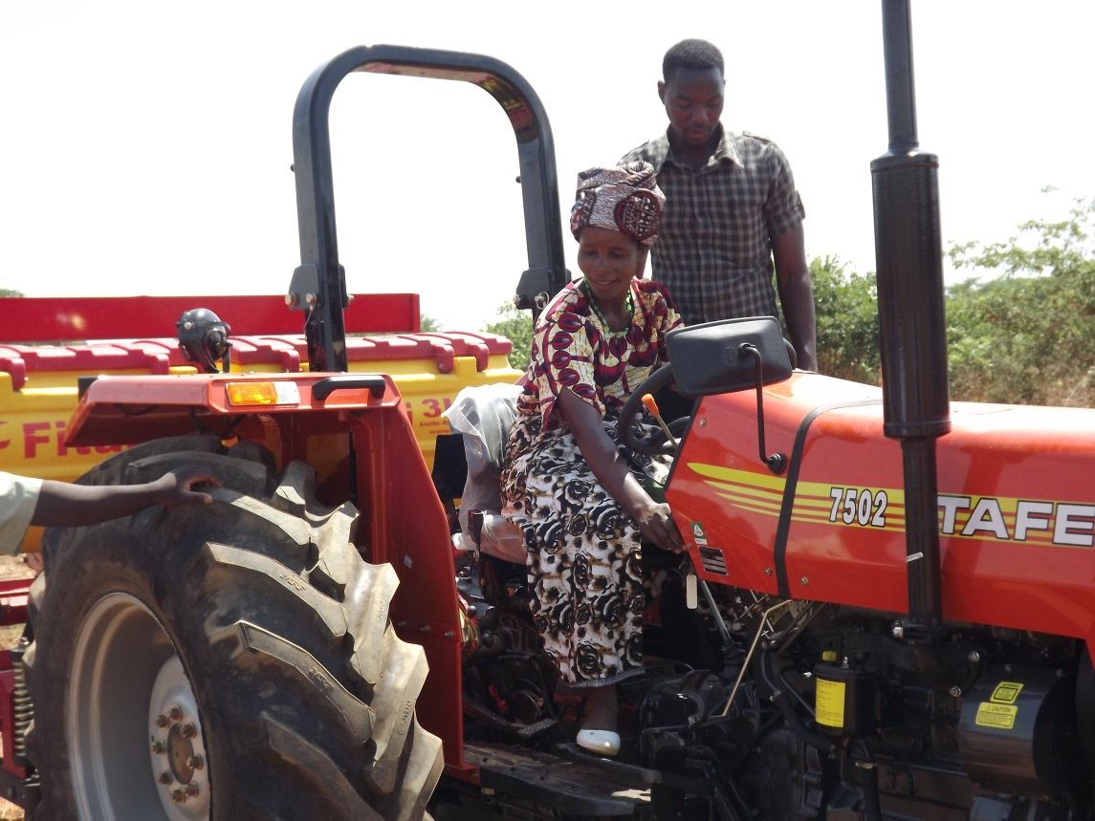  
  
Photo 2.8. Aliness, a trainee CA mechanization service provider receiving her first training on no-till planting with an FAO-supplied Brazilian Fitarelli direct planter. This training course was run in Zambia during November 2012 (photograph by Brian Sims, Engineering for Development, Bedford, UK).  
  
CA is tailor-made for agricultural contracting compared with conventional tillage, owing to the former’s simpler equipment (drawn by oxen, two-wheel or four-wheel tractors), its relatively low cost and rapidity of mechanized operations. CA also lends itself to efficient fertilization with phosphate and nitrogen in the rooting zone at planting time, these elements being most needed from germination onwards during early vegetative growth. Conventional farming in which DAP is applied after planting is inefficient, as it takes a long time for the ‘immobile’ P to reach the rooting zone, and the N is leached away.  The purple leaf tell-tale sign of phosphate deficiency is commonly seen in such late-fertilization situations.   
  
Yet there may be other ‘negative factors’ at work constraining adoption, as yet ‘unproven’, related perhaps to changing climate, land tenure/ security (see Chapter 6.3.1 in the companion book), the modest extension services available to promote the initiative compared with the task in hand, and/or because of the reduced dry season grazing available with CA compared with normal full tillage. There may be anthropological factors at work too. For instance, because full field ploughing had been promoted by government before Zambian independence, perhaps CA is regarded as a poor person’s technology, and belittled in the community ? The latter has been noted as a sociological constraint to CA adoption amongst Kikuyu farmers in Kenya. In an attempt to reveal the full picture of only modest uptake of CA, in 2014 the EU launched a short socio-economic study on the determinants of widespread CA adoption in Zambia.   
  
Though likely a controversial conclusion, the main reason why CA is not more widely adopted in Zambia may relate to the land ownership issue, previously mentioned. When farmers do not own the land they use, they are less concerned than they should be about soil erosion/ soil loss which can, and often does, occur under conventional tillage.  If farmers personally rather than communally owned their land, they would likely invest in better land husbandry, as their long-term livelihood and ability to feed their families depend on that land’s health and productivity.

*Tanzania:* the African Conservation Tillage Network (ACTN) has secured a grant from FAO to implement a CA project in Tanzania from 2015, which will involve the initial development of a CA strategic investment plan for medium and small farmers. This is in the sub-Saharan context of declining *per capita* food production, even though overall cereal production has trebled from 1961-2010, according to the African Human Development Report of 2012. The investment plan targets in particular the declining soil fertility and degradation which ACTN ascribes to low-input agricultural practices, and poor access to appropriate mechanization equipment and related services. A new agricultural business model needs to be developed, other than that run by the public sector, which has failed previously in Tanzania. This will likely be based on improved market-led capacity of producers and farmer organizations, and enhanced awareness on CA and its potential amongst farmers, the private sector and policy makers.

1.
2.
3.